We live in an era of increasing concern over the conservation and management of our renewable and non-renewable resources. We seldom think of soil in these terms, and yet improper development or natural erosion can devastate a landscape that nature took centuries to create. Similarly, the mineral elements in the soil that nourish growing plants can be depleted through repeated cycles of cultivation and harvest, resulting in an exhausted soil incapable of supporting healthy plant growth.
For this lab exercise you are taking on the role of a soil scientist. Soil scientists receive samples of soil from individuals in the community and it is your role to analyze the soil sample that you have been given to make a recommendation to the homeowner about the quality of their soil and what they can do to improve the fertility of the soil. You will determine the quality of the soil through physical, chemical, and biological testing.
Your final report will be a formal lab write up outlining the procedures that you followed (lab report format) and all data that was collected. In the conclusion section you will clearly outline what improvements you would make to the soil – be specific – based on YOUR lab results.

Physical Testing

1.Soil Profile: Take your trowel and dig a 6”x6”x8” square into the ground. Place removed soil into your soil cup provided to you. Once the soil is removed, look at the walls of your soil pit. Identify any layers/differences in color that indicates your soil profile. Sketch or take a picture of your profile. Use a ruler to mark each layer within the profile.

2. General Observations: Look closely at your soil sample. What do you see? Observe and comment on the various particle sizes. Do any sizes dominate? What does the color of your soil indicate?

Soil Texture: Soil is made of mineral particles belonging to three size categories: clay, silt, and sand. The size of soil particles is important. Large particles of sand allow empty space for air and water to enter the soil. Smaller silt and clay particles help hold the water in a soil so that it does not drain away too quickly to be of use to plants. The ratios of these materials, or texture, can be determined qualitatively and quantitatively.

3. Soil Texture by Feel: Use 25 grams of your sample to do the following experiment using the instructions below. Determine what type of soil you most likely have based on your results.

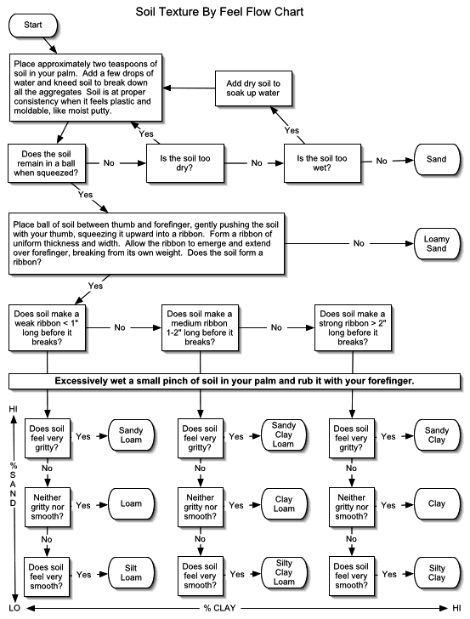
4. Soil texture by fractionalization: Sand has a larger particle size and so will settle out faster in a suspension, silt is the next in size so it settles out next with clay the smallest size particles so they will settle on top.

- Fill a graduated cylinder with 25 mL of your soil sample.
- Add water until there is about 75 mL in the cylinder.
- Add 5-6 drops of ammonium hydroxide (household ammonia) to separate the sand, silt and clay.
- Cover the cylinder with film and invert several times until the soil is thoroughly suspended in the water. Place the cylinder on the lab station and LEAVE IT to settle for at least 30 minutes.
- When the soil has settled out, there should be at least 3 distinct layers. Measure the volume of each layer and the total volume of soil for the sample (should be 25 mL).
- Calculate the percentage of each component in the table below.

% Sand | % Silt | % Clay

Using the soil triangle and the calculated data to determine what type of soil you have.

To include in Conclusion: How does your answer compare to the qualitative method? (Do you have the same type of soil in the “texture by feel” as you do the “texture by fractionalization”? If not, which is a better measure of soil type?)

Biological Testing

5. Soil Biodiversity: It is important for soil to have a rich diversity of organisms working to decompose organic matter and aerate the soil. Soil health can depend on the quantity of microfauna and mesofauna in the soil.

- Spread out a sheet of white plastic and empty your soil onto it. Use your hands to gently spread out the soil.
- Look for small creatures in the soil. If you find a minibeast, place into a small container.
- Try to determine what each minibeast is based on the provided reference chart.
- Keep a count of each different type of minibeast you discover and the number of organisms within a species.
- Create a bar graph to represent the number of each organism and the overall diversity of the soil.

To include in Conclusion: How does the biodiversity of the soil differ from one location to the next? Use the data from different locations around the school to discuss. Which type of organism was most prevalent? Why do you believe this is, based on the other soil features?

Chemical Testing

6. Fertility Analysis: Four variables are important in determining the fertility of soils. They are pH and the amounts of nitrogen, phosphorous, and potassium. The values of each of these components can serve as a limiting factor in the growth of plants.

- Use the soil test kit to determine the values of each variable (follow directions provided OR directions within the kit itself)

Test | Result - | Result -
Nitrogen
Phosphorous
Potassium
pH

Determine the health of your soil based on your results.

To include in Conclusion: Based on your results of these tests, which nutrients are low in your soil sample?
Using the textbook and any other RELIABLE resource, determine what can be done to your soil to improve its soil fertility. If there is nothing that needs to be done to the soil based on your tests, you also need to explain that and give support for that recommendation.

Enter your group lab results in the class spreadsheet.

Post-Lab Questions:

- What role does humus play in soil fertility?
- What components comprise a healthy layer of topsoil?
- Why are we losing topsoil at alarming rates? What can be done to prevent and stop further losses of topsoil?
- What are the layers in a soil profile called? List and briefly describe each layer that is represented in an ideal soil profile found in a coniferous forest biome found in the North Carolina piedmont.
- Why is pH such an important aspect of soil fertility?
- What are some natural sources of the nitrogen, potassium and phosphorous found in soil?
- By what process is atmospheric molecular nitrogen (N2) converted into a form that plants can readily absorb through their roots? What form of nitrogen is this?
- How are the three primary plant nutrients used by living organisms?
- Evaluate the fertility of the soil used in this lab activity based upon your results. Specify your reasons.
- What types of vegetation does soil of the type and pH you sampled best support?
- How does the biodiversity of the soil used in this lab activity compare to that of other nearby locations (other groups)? What factors may impact/limit the amount of biodiversity for the soil used?
- What are some possible sources of error in this experiment?

