APES- Water Diversions
Name:

Purpose: Conduct research to analyze the effects of water diversions on surrounding ecosystems and human communities. Compare and contrast the problems and successes of various water diversions and describe possible remediations.
Introductions: Humans have been diverting water for irrigation, flood control, and a constant drinking supply for thousands of years. When populations were small, the diversions were small. Over the last 150 years, human populations have grown rapidly and our technical abilities have vastly improved. These two changes, worldwide, have led to many large-scale projects that have altered the environment of sizable regions. This investigation focuses on three major water diversions: The Salton Sea, Lake Chad, Aral Sea, Mono Lake, Yangtze River, and The Colorado River.
Salton Sea

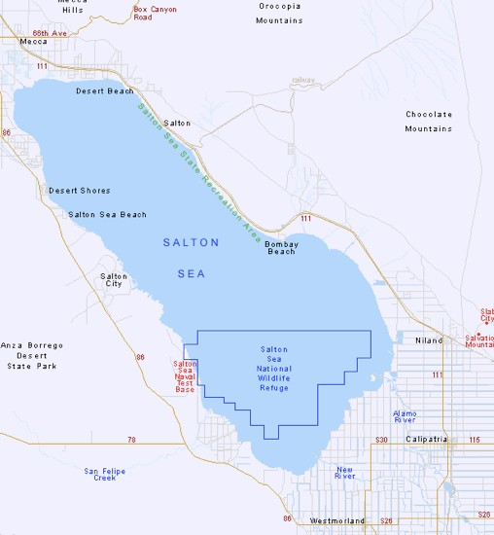1: Describe the location of the Salton Sea. What is the climate and geography of the area?

2: How did the Salton Sea form?

Explain what role humans played.

3: What is the present condition of this body of water? How has it changed over the last

25 years? Why?
4: Describe several ways the Salton Sea has altered the ecosystem of the region. Explain the stability of that ecosystem. How is it changing over time?

5: Outline 3 environmental and 3 economic reasons the Salton Sea is important.

6: What steps are being taken to remediate the Salton Sea? What are the chances of success? Explain.

7: Compare the similarities and differences between the Salton Sea and Lake Chad in
Sub-Saharan Africa. (Make a VENN Diagram)

The Aral Sea

1: Where is the Aral Sea located?

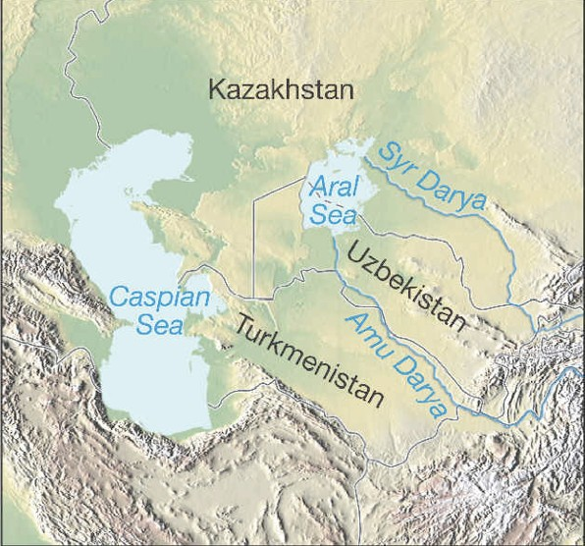3: What government agency is responsible for the Aral Sea and its plight?

4: Why was the water supply to the Sea
diverted?

5: What resources did the Aral Sea supply to the local inhabitants?

6: Describe 3 negative environmental effects of the fading of this sea.

7: Describe 3 economic impacts in the region because of the water diversion.

8: How is the situation of the Salton Sea similar to the Aral Sea? How is it different?

9: How would you describe this region today, other than as a “sea”?

10: Explain five health effects on people related to the vanishing Aral Sea.

12: Compare the situation in Mono Lake, California with that of the Aral Sea

• How did the Mono Lake problem arise?

• Describe 3 ways the problems of Mono Lake are similar to those of the Aral Sea

• Outline three ways the problems of Mono Lake differ

13: Summarize the proposal and actions to remediate Mono Lake

Colorado River Basin

1: Compare water diversion influences on the Colorado River with those on the Salton
Sea and the Aral Sea. Describe three ways they are different.
What are some of the main tributaries and their source?

What is the most important origin of the water in the Colorado River?

3: Politics: Who decides where the water in the river system goes? How is the resource divided between the various states in the watershed and beyond?

4: How do the individual states use the water? Who are the top five consumers of the water?

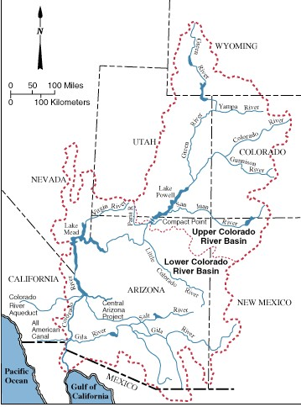5: Describe some of the conflicts that arise over water use. How are they usually resolved?

6: How are conflicts between public and private use managed?

7: Serious differences with Mexico exist concerning the amount of water the Mexicans receive from the river. Explain why this problem exists and what can be done to work out this dispute between the countries.

8: The Tigris and Euphrates Rivers cross international boundaries in their path to the Persian Gulf. Why is this problem potentially greater than the one that exists on the Colorado River?

9: Compare the problem of water diversions on the Yangtze River in China with those of the Colorado River.

10: The Three Gorges Dam on the Yangtze River is very controversial. Why is this dam being built?

11: Describe how this dam differs from dams on the Colorado River, such as the Glen
Canyon Dam or Hoover Dam, with respect to:
• the disruption of human life
• impact on the environment
• archaeology
• local culture and natural beauty

