Energy Transfer: Owl Pellets

Objectives After this lab you should be able to do the following:
- Dissect Owl pellets and Identify the bones.
- Use bone counts to estimate the types of animals an owl eats in a region.
- Estimate the amount of energy transferred to an owl.

Materials Materials for this lab are:
Owl Pellet Samples
Wooden Probes
Large beakers
Paper Towels
Identification Tables (in lab)

Lab Hazards Pay attention while dissection pellets so as not to hurt anyone. Students with severe allergies should not directly handle owl pellets

Introduction Most birds cannot chew their food and owls are no exception. Owls usually swallow their prey whole. However, owls differ from other species of birds because they do not have a crop, the baglike organ used to store food after it has been swallowed so that it can be digested later. In owls, food passes directly from the mouth to the gizzard. The gizzard is an organ that uses digestive fluids and bits of sand and gravel to grind and dissolve all of the usable tissue from the prey.
The types of tissue that can be dissolved by an owl's digestive system include muscle, fat, skin, and internal organs. These tissues are broken down into a variety of nutritional substances by the owl's gizzard and intestines. Some of these tissues (e.g., fur and bones) cannot by digested. This material, along with other waste collected throughout the body, is ejected from the vent, which is the combination reproductive and excretory opening in birds. The pasty white excrement is known as urea. It is very rich in nitrogen and similar to urine in mammals, only thicker.
But what happens to the indigestible material? Indigestible material left in the gizzard such as teeth, skulls, claws, and feathers are too dangerous to pass through the rest of the owl's digestive tract. To safely excrete this material, the owl's gizzard compacts it into a tight pellet that the owl regurgitates. The regurgitated pellets are known as owl pellets.
Owl pellets are useful to researchers because they can find out quite a bit about an owl's lifestyle through careful examination of the pellet's contents. Since most of the prey's bones are not actually broken during the attack and the subsequent digestion process, they can be readily identified in the pellet. Most pellets include a skull or skulls, which makes identification of the prey relatively simple. If multiple prey are consumed in a short period of time, then only one large pellet is formed from their remains.
Owl pellets have helped archeologists determine the age of Neanderthal and Cro-Magnon bones. Carbon dating can give a reasonably accurate estimate of the age of the bones inside of an owl pellet. As a result of the carbon dating of owl pellets excavated near the bones of Neanderthals and Cro-Magnons in Europe, anthropologists now theorize that these 2 species lived at the same time.
Large owls are obviously capable of making large pellets. However, since large owls do not always eat large prey, one cannot always determine the size of the owl that left a given pellet solely based on the size of the pellet. In addition, a startled owl may eject a pellet that is not fully compacted, thereby giving the pellet a larger appearance than normal. Other species of birds such as hawks and eagles produce pellets, but they are smaller and contain fewer animal parts than those produced by owls.
An owl pellet generally reaches its final form a few hours after the owl has eaten. However, the pellet is not usually ejected immediately after it is formed. Owls can store a pellet in a structure known as the proventriculus for as long as 20 hours before disgorging it. Since the stored pellet partially blocks the entrance to the digestive system, it must be ejected before the owl can eat again. Young owls do not produce pellets until they have begun to eat their prey whole.
The actual process of regurgitating a pellet lasts from a few seconds to several minutes. The pellet is forced out by spasms of the owl's esophagus. These spasms make the owl look like it is coughing painfully. However, it is not hurt by the process because the pellet remains soft and moist until it leaves the owl's body.
Identifying pellets
The shape and texture of a given owl pellet depends on the species of the owl that produced it and the type of prey that the owl consumed. Some pellets are tightly compacted, oval, and furry. Others are loosely compacted with an irregular shape. Pellets are moist when they are first ejected, but quickly dry out and start to decompose once they leave the owl's body. Owl pellets are typically found near places where owls perch, such as under trees and near barns.
Barn Owl pellets are typically medium sized, smooth, cylindrical, and dark. The tiny Elf Owl has a very small pellet that is dry and loosely compacted, a result of its largely insect diet. The Great Horned Owl can produce pellets that are 3-4 inches long. These pellets are usually cylindrical and tightly compacted. The exterior of the pellet can vary greatly due to the vast array of prey that Great Horned Owls consume.
Data Analysis How owls eat can be matched to you. If you are counting calories, it is not enough to simply know how many things you eat, but how many calories each thing is (a pound of lettuce is very different from a pound of beef) For owl you need to know more than how many of each prey animal that the barred owl eats because the animals are different sizes. The owl might have eaten a greater number of mice than rats, but because the rat is so much larger, the owl might have gotten more "food" from the rats.
If you had 3 hamburgers for lunch and 17 French fries (single pieces), you would probably feel stuffed. We could calculate the percents of your diet like this:
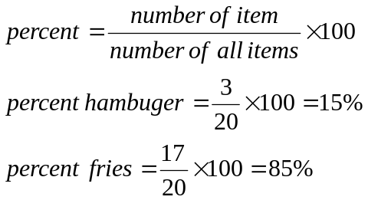
The percents show that you eat a higher percent of fries but it would be the hamburgers that filled you, not the French fries. We use the biomass for each prey, we are taking into account how heavy the sample is. We get biomass units by multiplying the number of each sample by a conversion factor that is based on the weight. For example above a table would look like this (since a hamburger is about 25 times the mass of a French fry, the biomass is 25 times more)
Prey | Frequency | Percent Diet | Conversion Factor | Biomass Units | Percent Biomass
Fries | 17 | 85% | 1 | 17 | 20%
Burgers | 3 | 15% | 25 | 75 | 80%
Even though you ate more fries, it got 80% of food from the burgers and only20% from the fries.
Pre-lab Questions 1. Research to find out often an owl will produce an owl pellet or how many pellets an average owl will produce in a year.
2. Suppose you want to find out what the following animals eat. What methods would you use? Explain how each is a valid method.
- Wild Horses
- Foxes
- Elephants
- Ants
3. How might learning what an animal eats help us protect that animal?
4. Construct a data table that has 5 columns and 6 rows. Give the rows the following headings as follows:
Species | Number of Skulls | Number of Jaws | Number of Pelvis’s | Estimated # of animals

Procedure Check that you have an owl pellet, two wooden probes, an owl pellet bone chart, a Rat Skeleton chart, and a sheet of white paper. READ BOTH METHODS OF DISCECTING THE PELLET BEFORE STARTING.
Method 1
- Place the owl pellet on the white paper. Using your fingers or the skewers, break off a small chunk of the pellet. Be gentle and do not push the skewers any further into the pellet than necessary. Remember, the bones you are looking for are small and easily broken.
- Carefully tear the pellet apart with the skewers and set aside any bones that you find in it.
- Compare the bones with the ones pictured on your Owl Pellet Bone Chart. Rats, mice, voles, and pocket gophers are some of the rodents that barn owls eat.
- Try to keep track of the bones by placing the ones you find over the matching bones on the rat skeleton chart. The animals eaten by the owl that produced your pellet may not have included a rat, but the bones of other rodents will be similar.
- Repeat this process until you have completely taken apart the pellet and removed all the bones. (skip to 6)

Method 2
- Place the owl pellet into a beaker with water. Use the skewers to break up the owl pellet. Fur and feather will eventually float to the top of the water while bones will fall to the bottom.
- Skim off the fur and use the skewers to collect bones onto a paper towel. Use the skewers to clean excess fur and feather from the bones.
- Compare the bones with the ones pictured on your Owl Pellet Bone Chart. Rats, mice, voles, and pocket gophers are some of the rodents that barn owls eat.
- Try to keep track of the bones by placing the ones you find over the matching bones on the rat skeleton chart. The animals eaten by the owl that produced your pellet may not have included a rat, but the bones of other rodents will be similar.
- Repeat this process until you have completely taken apart the pellet and removed all the bones.
- Record your findings by completing the first chart you created in the pre-lab.
- Compare your findings with those of classmates. Copy and complete the chart below with information from the class.
Lab Questions 1. Use the information you have collected to estimate the total biomass an owl consumes in a year. What would you use to calculate this number?
2. In class we have stated that as you move along the food chain the amount of biomass decreases by a factor of 10. Sketch a food chain for owls, label producers and consumers. Use the biomass you calculated in the last question to create a trophic pyramid showing the amounts of each portion of the food chain.
3. What information can we gleam from the pellets about the habitat the owl lives in. What type of habitats would provide drastically different results?
4. What might happen to the population of owls if there were a sudden population explosion of mice? What might happen if the owl population suddenly decreased?
Beyond Lab Collect the bones, together. Attempt to reassemble the skeleton on a note card.

OWL PELLET PREY ANALYSIS DATA CHART
Prey | Mean  Mass (g) | Conversion  Factor | Frequency  Found | Percent of Diet | Biomass Units | Percent of Biomass
Vole | 40 | 2
Mouse | 20 | 1
Mole | 55 | 2.75
Shrew | 5 | .25
Rat | 240 | 12
Small Bird | 40 | 2
 |  | Totals |  | 100% |  | 100%
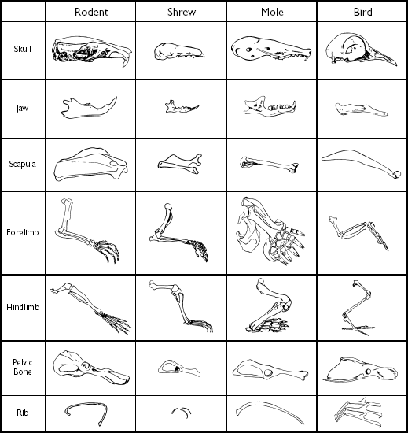
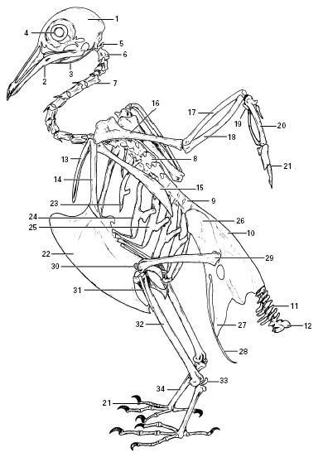

Bird Skeleton

- Skull
- Mandible
- Hyoid
- Eye bone
- Atlas
- Axis
- Cervical vertebra (15)
- Thoracic vertebra (5)
- Lumbar vertebra (6)
- Synsacrum
- Caudal vertebra (15)
- Pygostyle
- Clavicle
- Coracoid
- Scapula
- Humerus
- Radius
- Ulna
- Carpus
- Carpometacarpus
- Phalanges
- Sternum
- Cervical ribs
- Thoracic ribs
- Uncinate process
- Ilium
- Ischium
- Pubis
- Femur
- Patella
- Fibula
- Tibiotarsus
- Sesamoid
- Tarsometatarsus

Mole skeleton
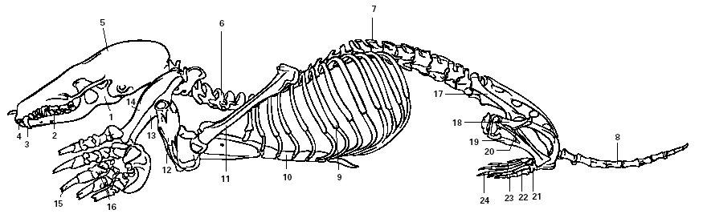

- Mandible
- Molar
- Canine
- Incisor
- Skull
- Cervical vertebra
- Lumbar vertebra
- Caudal vertebra
- Ribs (13)
- Sternum
- Scapula
- Humerus
- Radius
- Ulna
- Claw
- Phalanges
- Pelvic bone
- Femur
- Tibia
- Fibula
- Tarsus
- Metatarsus
- Phalanges
- Claw

Rat Skeleton

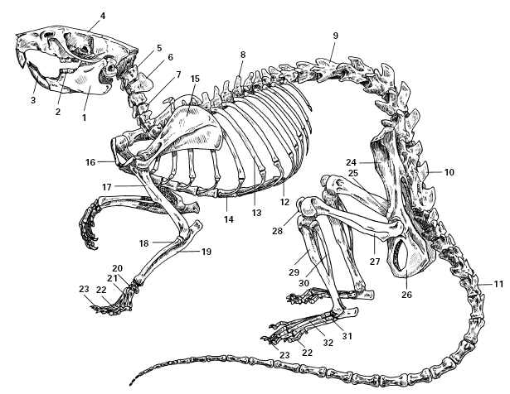

- Mandible
- Molar
- Incisor
- Skull
- Atlas
- Axis
- Cervical vertebra (7)
- Thoracic vertebra (13)
- Lumbar vertebra (6)
- Sacrum (3)
- Caudal vertebra (28–30)
- Xiphoid process
- Rib (13)
- Sternum
- Scapula
- Clavicle
- Humerus
- Radius
- Ulna
- Carpals
- Metacarpals
- Phalanges
- Claw
- Ilium
- Pubis
- Ischium
- Femur
- Patell
- Tibia
- Fibula
- Tarsus
- Metatarsus

