- Nutation
Definition: A periodic oscillation (nod) of the Earth’s axis that causes the precession of the poles to follow a wavy rather than smooth circular path.
The Activity: Watch the video of the Earth’s precession.
Questions:
- Explain what nutation is in your own words.
- What causes nutation to occur based on the text provided on the website.
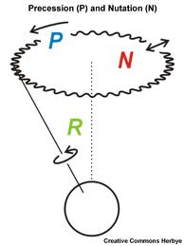
http://space-geodesy.nasa.gov/multimedia/EarthOrientationAnimations/nutationAndPrecession.html

- Barycenter (Part 1)
Definition: the common center of mass around which two or more bodies revolve. Because of the difference in mass, the Earth-Moon barycenter is 1,710 km below the Earth’s surface.
The Activity:
- Place the two different balls of clay on each end of the hanging rod.
- Make sure there is equidistance between each ball and try spinning.
- Next, try to find the barycenter of the two balls and then spin again.
- Measure the distance between the barycenter and each ball using the ruler.
Questions:
- Which end of rod is the barycenter closer to?
- Why does it work this way?
- Based on your observations, explain why the Earth-Moon barycenter is determined to be below Earth’s surface.
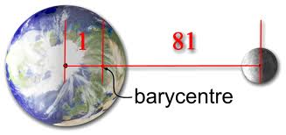
barycenter

http://www.education.com/science-fair/article/barycenter-balancing-point/

3. Precession
Definition: the slow, circular, change in direction of the Earth’s axis as it rotates. This 26,000-year cycle causes the “North Star” to change.
The Activity: Watch the video on precession and then, practice viewing precession by spinning the top.
Questions:
- Is the precession more noticeable when the gyroscope is going faster or slower?
- Approximately how long does 1 precession of the Earth take?
- Why do astronomical maps & charts become outdated every 50-100 years?

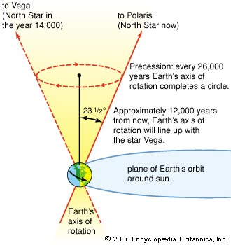
https://www.youtube.com/watch?v=0qHjtp4cdCA

- Rotation
Definition: An orbital body (star, planet or moon) turning on its imaginary axis. Rotation causes differences in time, date, light and gives the Earth its shape.
The Activity: Watch the two videos on Earth’s rotation and the Moon’s rotation.
Question:
- How long does it take Earth to make one rotation?
- In which direction does the Earth rotate?
- What is caused by Earth’s rotation around the sun?
- Why do we only see one side of the moon?
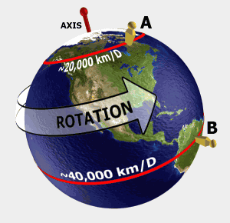
https://www.youtube.com/watch?v=pLl8sDZRSYg
https://www.youtube.com/watch?v=exIpL0Uhr_k

- Revolution
Definition: The path a planet takes as it goes around its star or the path a moon takes as it goes around its planet.
The Activity: Choose the preset “Sun & Earth”. Move the sliding bar on the right side to select different planets. Click anywhere in “space” to add more planets. Be patient and watch what happens.
Questions:
- What affects the speed of a planet’s rotation?
- How long does it take Earth to make a complete revolution?

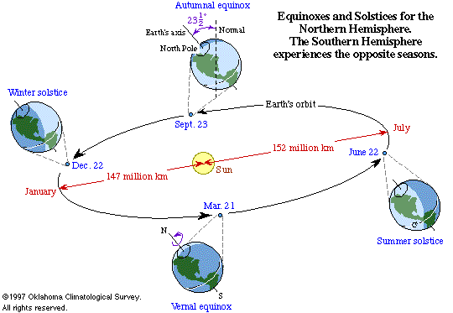

http://highered.mcgraw-hill.com/olcweb/cgi/pluginpop.cgi?it=swf::800::600::/sites/dl/free/0072482621/78780/Solar_Nav.swf::Solar%20System%20Builder

- Nebular Hypothesis (Part 1)
Definition: A rotating cloud (nebula) of dust and gas stuck together to form the solar system.
The Activity: Stir the powder in the beaker of water. Watch for changes in how it clumps as the mixture slows down. Next, watch the video.
Question:
1.Where does most of the “stuff” collect in the Beaker?
2. What is in this location in our solar system?
3. Based on question 2, what is this model of the solar system known as?
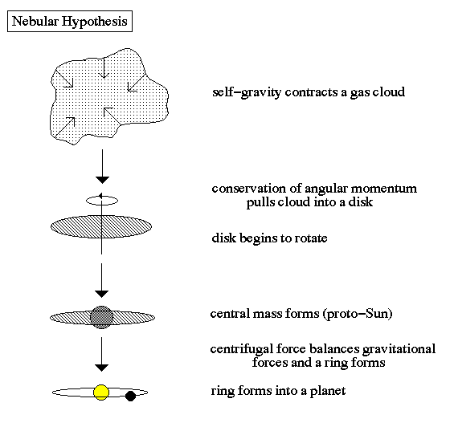
https://www.youtube.com/watch?v=Uhy1fucSRQI

6. Centripetal Force (Part 2)
Definition: A force that keeps objects moving toward the center of a circular path.
The Activity:
Watch the demonstration video. Try them yourself: Quickly shake the balloon in a spinning fashion. Watch the penny inside. Next, swing the cup of water as directed by the teacher. Be careful to be in an open space away from other students.
Question:
1. Explain what the penny does inside the balloon.
2. Explain what the water does, or doesn’t do, in this experiment.
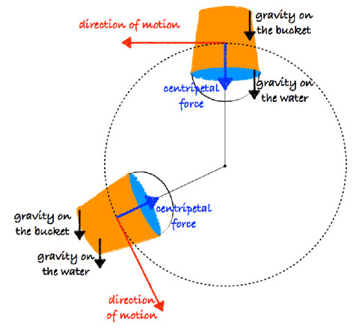
https://www.youtube.com/watch?v=yyDRI6iQ9Fw

- Retrograde Motion
Definition: An illusion where planets appear to change direction in the sky. This is caused by the Earth passing the slower moving outer planets as they orbit.
The Activity: Watch the video on the computer for the retrograde motion of Mars in the summer of 2003. Read the website to answer Question 2.
Questions:
1. On your paper, draw a line that shows how Mars appears to travel through the sky.
2. Which planet has real retrograde (backwards) motion as it rotates?
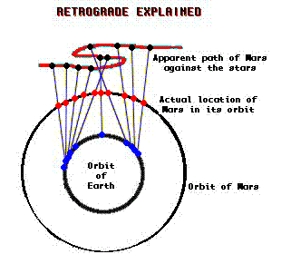
http://earthsky.org/space/what-is-retrograde-motion
8. Oblate Spheroid
Definition: The true shape of the Earth, flattened at the poles and bigger at the equator. This is caused by the Earth flattening out as it rotates.
The Activity: Watch the video.
Question: Explain why the geographic poles are not in the same place as the geomagnetic poles.
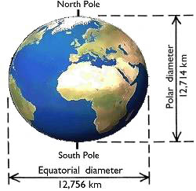
http://www.universetoday.com/104177/why-the-north-pole-is-really-a-south-pole-and-vice-versa/
- Barycenter and Balance (Part 2)
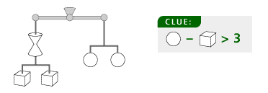
Information: The Sun’s gravity pulls on the planets and the planets’ gravity pulls on the Sun. This causes the Sun to move slightly in the solar system, but never too far from the solar system’s barycenter.
Additional Clues:
The total weight is 36.
All shapes weigh less than 10.

The Activity: Study the puzzle on this sheet. Discover the value of each of the shapes.
Questions:
1. What is the value of the circle?
2. What is the value of the cube?
3. What is the value of the double cone?

