WATER-QUALITY TESTING

INTRODUCTION: An ecosystem is a community of different species interacting with one another and with the abiotic environment of matter and energy. The size of an ecosystem is somewhat arbitrary; it is defined by the particular system we wish to study. The unit of study may be relatively small, such as a particular stream or field or a patch of woods, desert, marsh or even your microhabitat from a previous lab. Or the units may be large, generalized types of terrestrial ecosystems such as a particular type of grassland, forest, or desert. Ecosystems can be natural or artificial. Examples of artificial ecosystems are crop fields, farm ponds, reservoirs, artificial lakes, or our own campus Eco-Studies Pond.

Water Quality Index
The Water Quality Index (WQI) was developed in the early 1970s in an effort to compare the quality of water from all parts of the country. Over one hundred water-quality experts were called together to create this standard means of using one number to represent nine criteria for calculating the degree of water quality for a given body of water. The results are used to decide whether the water may be considered healthy, to monitor it over time, and to assess it relative to any other body of water on Earth.
This investigation prepares you to perform most of the nine tests to determine the WQI for our own Eco-Studies Pond. (Due to the fact that we are not equipped to perform all nine tests, we will approximate the WQI for our Eco-Studies Pond.) Usually these tests are repeated several times to get a full picture of how an ecosystem may change over a period of time. Below are outlined the bases for these tests and what the tests measure.

Dissolved Oxygen (DO): Oxygen is not very soluble in water. What little gets into solution is vital to aquatic life and water quality. Most oxygen dissolved in streams, rivers, and lakes gets there by contact with the atmosphere. In streams and rivers, water splashing over rocks and waterfalls (as in our Eco-Studies Pond) traps oxygen in the water. Waves on rivers and lakes also increase the oxygen level in solution. Photosynthetic plants in the water also contribute a significant amount of oxygen to the water column.
This test determines the amount of oxygen that is dissolved in the water and is available to the aquatic life that lives there. If the DO levels are too low, fish can drown. A DO that is too low is often an indicator of possible water pollution. It also shows a potential for further pollution downstream because the ability of the stream to self-cleanse will be reduced.

pH: Pure water contains an equal amount of H⁺ and OH⁻ ions. Hydrogen ions are acidic and hydroxide ions are basic, or alkaline. pH measures the –log of the H⁺ concentration. A pH of 7 is neutral; it is equally acidic and alkaline. pH values below 7 become more acidic and they approach zero as the H⁺ ions increasingly outnumber the OH⁻ ions. As the values climb above 7, the water is said to be basic. The water becomes more alkaline as the values approach 14 and the OH⁻ ions outnumber the H⁺ ions.
Many aquatic life forms are very sensitive to acid levels in the water. Pollution tends to make water acidic. Most bodies of water have the highest biological diversity when the pH is near 7.

Temperature: Water temperature is a very important parameter for a body of water. Most physical and biological processes are affected by the temperature. Most aquatic life requires an optimum temperature range to thrive and, like terrestrial life, finds survival difficult at extreme temperatures. Higher water temperatures lower the amount of dissolved oxygen for two reasons. First, all gases are less soluble in warmer water. Second, warmer water increases the metabolic rate of aquatic organisms, which increases the consumption of food and dissolved oxygen.
The increase of water temperature is called thermal pollution, and it is a significant problem on some bodies of water. Most thermal pollution comes from the industrialization of rivers and waterways. Industries, especially large power plants, use large amounts of water to cool their machinery and equipment. Along smaller bodies of water, cutting trees takes away the shade and allows water temperatures to rise along riparian habitat. Another cause, large-scale logging, increases soil erosion and water turbidity (cloudiness), which, in turn, raises the water temperature to the detriment of aquatic life.

Fecal Coliform: Coliforms are a form of bacteria that are found in the intestines of warm-blooded animals; their presence in lakes, streams, and rivers is a sign of untreated sewage in the water. Fecal coliforms can get into the water from untreated human sewage or from farms and runoff from animal feed lots. While fecal coliforms themselves are not harmful to humans, their measures indicate the presence of harmful pathogens.

Biological Oxygen Demand (BOD): Aerobic bacteria in water eat organic matter and at the same time remove oxygen. When the organic material in dead aquatic plants is decomposed, it releases the nutrients nitrogen and phosphorous. These nutrients trigger more plant growth and more nutrients, which further lower oxygen levels. If there is too large an amount of organic material in the water, the oxygen levels can drop below what is necessary for other aquatic life forms.
The BOD test gives an approximation of the level of biodegradable waste there is in the water. This biodegradable waste can be leaves and grass clippings from human activities, animal waste and manure from food production, wood pulp from paper mills, or many other carbon-based wastes. Water with a high BOD usually has a high bacteria count as well.

Nitrates (NO₃ˉ): Nitrates are a crucial nutrient in aquatic environments for synthesis of amino acids and proteins, but serious problems can result from eutrophication, or excessive nutrient levels. Excess nitrates get into waterways as non-point source fertilizers and from defective septic and sewage treatment systems. Nitrates can also get into the water from natural processes related to the nitrogen cycle. Most excessive amounts of nitrates come from human-based activities such as runoff from fertilized land, animal wastes from feedlots, and treated municipal waste effluent. Nitrate pollution effects both surface and ground water. It has been implicated as the primary cause of the dead zones in the Gulf of Mexico, the Chesapeake Bay and Long Island Sound. Nitrates also get reduced to nitrites, which can be harmful to humans and fish.

Total Phosphates (PO₄³ˉ): Phosphates are another essential nutrient for aquatic plants, but only in very low concentrations. Excessive amounts of phosphorous build up easily, and small amounts can contaminate large volumes of water. Phosphorous gets into water from many sources, such as fertilizers, sewage and detergents. Phosphorous exists in water in both organic and inorganic forms.

Total Dissolved Solids (TDS): Solids can be found in water in two forms, dissolved or suspended. Dissolved substances will pass through any filter commonly used in a lab. Suspended solids will be stopped by a filter because they are larger than individual atoms, ions, and molecules. This test measures the many solids found dissolved in water, usually in the form of such ions as sodium (Na⁺), magnesium (Mg²⁺), calcium (Ca²⁺), chloride (Cl⁻), hydrogen carbonate (HCO₃⁻), and sulfate (SO₄²⁻).
Solids soluble in water can also be organic, though they are usually salts. A steady concentration of dissolved minerals is necessary for aquatic life—both as essential nutrients and to maintain the osmotic balance with the cells of organisms. Changes in concentration can lead to a weakening of the organism or even death. High levels of TDS can affect water clarity and photosynthesis and lead to a decline in the quality and taste of drinking water. Some sources of dissolved solids are road salts in winter, urban runoff through storm sewers, farm chemicals, sewage treatment effluent, and factors that increase soil erosion such as road building and clear-cut logging.

Turbidity or Total Suspended Solids (TSS): This is a measure of how light is scattered in the water column due to solids that do not dissolve but are small enough to be suspended in the water. The higher the turbidity, the murkier (cloudy) the water. Turbidity keeps light from penetrating into the water and interferes with plant photosynthetic oxygen production and primary productivity. Darkened water holds more heat, increasing the water temperature which in turn lowers the DO. Suspended solids can clog fish gills and, in the case of silt and clay settling to the bottom, also smother larvae and fill in nesting sites. These solids may come from soil erosion or channelization from dredging. Increased water flow rates erode stream banks and allow the water to carry a heavier load of particles, storm and sanitary sewage effluent, and increased algae growth.

OBJECTIVE: Perform tests to determine the water quality of a local body of water

MATERIALS: Secchi disk Thermometer ChemKits (DO, Nitrates, Phosphates)
Magnifying Glasses Chemical Strips Collection Nets
Macroinvertebrate Key Solution Waste Container

PRE-LAB QUESTIONS:

1. Why is rain water normally slightly acidic?
2. Why are oxygen-demanding wastes pollutants?
3. How does B.O.D. relate to D.O.?
4. What are ways in which sedimentation occurs in waterways?
5. What is the impact of sedimentation on aquatic species?
6. What is the impact of warmer aquatic temperatures on aquatic species?

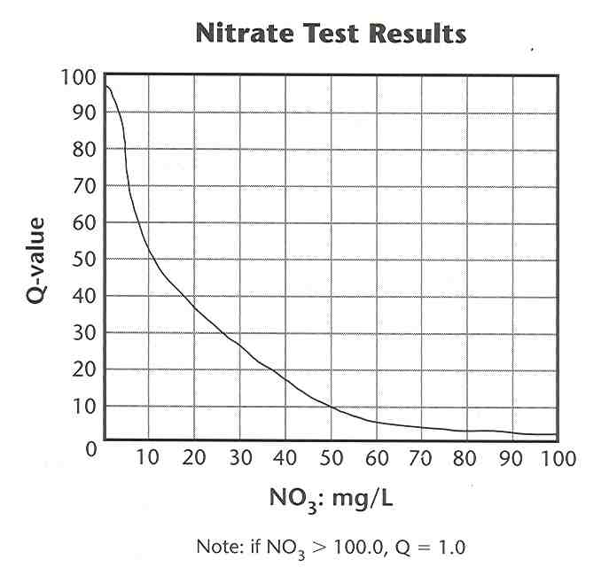
PROCEDURES:
Station 1 - CHEMICAL TESTING (Part A)

NITRATES (NO₃ˉ)
- Follow the directions in the CHEMets Kit for Nitrates.
- Compare the colored solution to the reference samples.
- Convert to ppm (mg/L) by multiplying result by 4.4.
- Determine the quantitative mg/L value for NO₃ˉ as follows:
Low NO₃ˉ: 17.5 mg/L
Medium NO₃ˉ: 50.5 mg/L
High NO₃ˉ: 83.0 mg/L
- Record the quantitative value for phosphates.
- Using the graph, determine the Q-value for NO₃ˉ.
- Record the Q-value for NO₃ˉ.
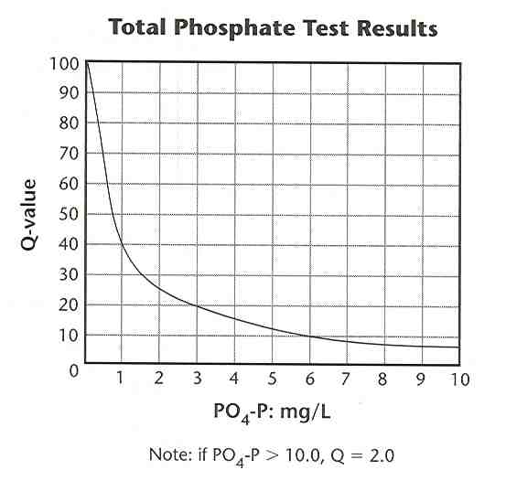
- Discard ampoule and waste water into WASTE CONTAINER.

PHOSPHATES (PO₄³ˉ)
- Follow the directions in the CHEMets Kit for Phosphates.
- Compare the colored solution to the reference samples.
- Determine the quantitative mg/L value for PO₄³ˉ as follows:
Low PO₄³ˉ: 1.8 mg/L
Medium PO₄³ˉ: 5.1 mg/L
High PO₄³ˉ: 8.3 mg/L
- Record the quantitative value for phosphates.
- Using the graph below, determine the Q-value for PO₄³ˉ.
- Record the Q-value for PO₄³ˉ.
- Discard ampoule and waste water into WASTE CONTAINER.

DISSOLVED OXYGEN (DO)
- Follow the directions in the CHEMets Kit for Dissolved Oxygen.
- Record the DO value.
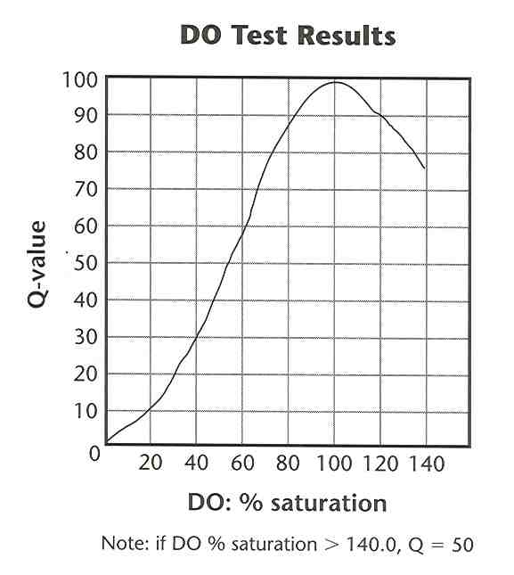
- Determine the % saturation from the nomograph below.
- Record the % saturation.
- Determine the Q-value for DO % saturation using the graph.
- Record the Q-value for DO % saturation.
- Discard ampoule and waste water into WASTE CONTAINER.
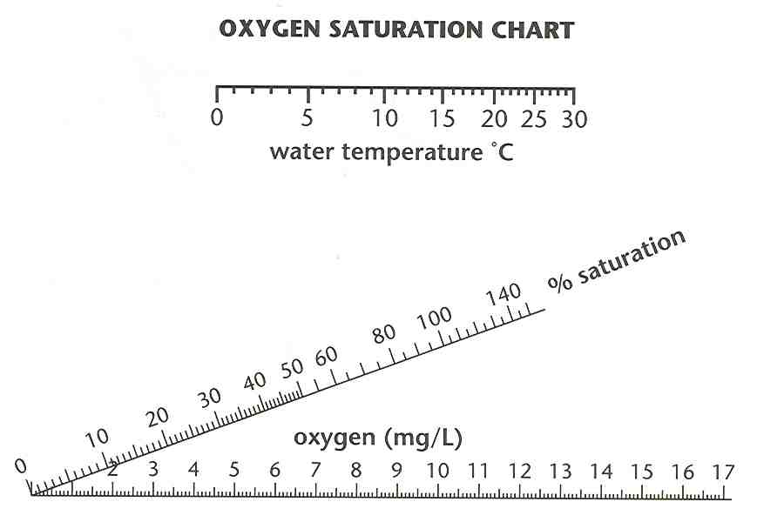

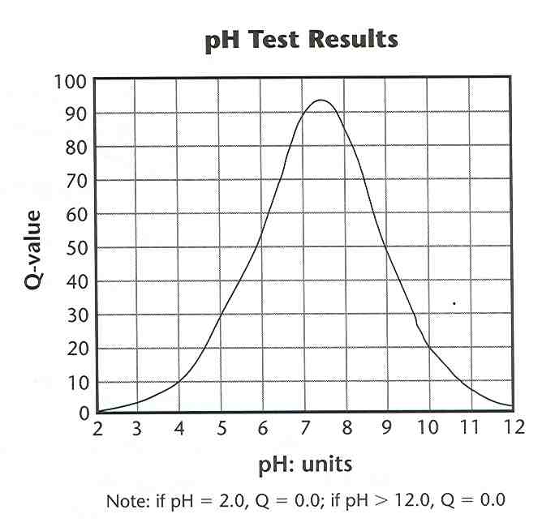
Station 2 - CHEMICAL TESTING (Part B)

pH
- Collect a sample of pond water.
- Use the pH strip to determine the pH of the pond water.
- Record your pH.
- Determine the Q-value for pH using the graph below.
- Record the Q-value for pH on the DATA TABLE.
- DISCARD solution and strips into WASTE CONTAINER.

OTHER CHEMICAL TESTS

- Collect a sample of pond water.
- Use the other test strips provided to determine the following:
  - Iron content
  - Copper content
  - Hardness
  - Alkalinity
- Record your data.
- DISCARD solution and strips into WASTE CONTAINER.
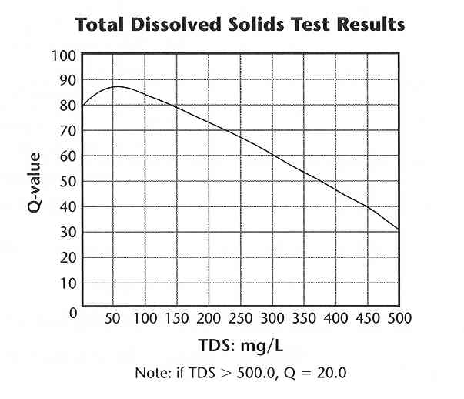

Station 3 - PHYSICAL TESTING

TOTAL DISSOLVED SOLIDS (TDS)
INSTRUCTOR WILL PROVIDE
- Your Instructor will provide you with the mass of the dissolved solids.
- Record the mass of the dissolved solids.
- Multiply the mass of the dissolved solids by 5 to calculate the Total Dissolved Solids in mg/L.
- Record the Total Dissolved Solids value.
- Using the graph, determine the Q-value for TDS.
- Record the Q-value for TDS.

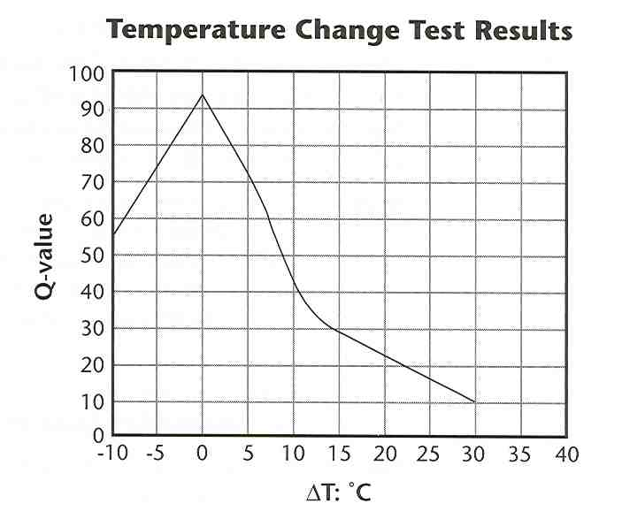

TEMPERATURE CHANGE, ΔºC
1. Determine the water temperature of the pond near the road.
2. Determine the water temperature of the pond on the other side, away from the road.
3. Calculate the difference (ΔºC) and record the value.
4. Determine the Q-value for ΔºC using the graph below.
5. Record the Q-value for ΔºC.

TURBIDITY or TOTAL SUSPENDED SOLIDS (TSS)
- Use the secchi disk by placing down into the water until you can no longer see the disk. Begin raising up slowly until you can see the plate. Measure the distance on the rope from the top of the water to the top of the secchi disk in inches.
- Record the depth of turbidity.
- Using the graph, determine the Q-value for TSS.
- Record the Q-value for TSS.
- Next place a sample of pond water into the container and read the turbidity. Record your results.
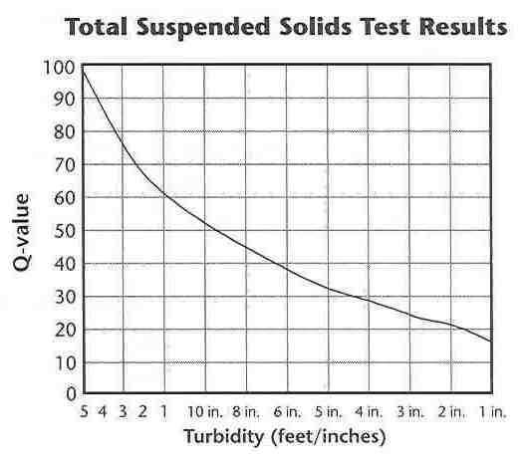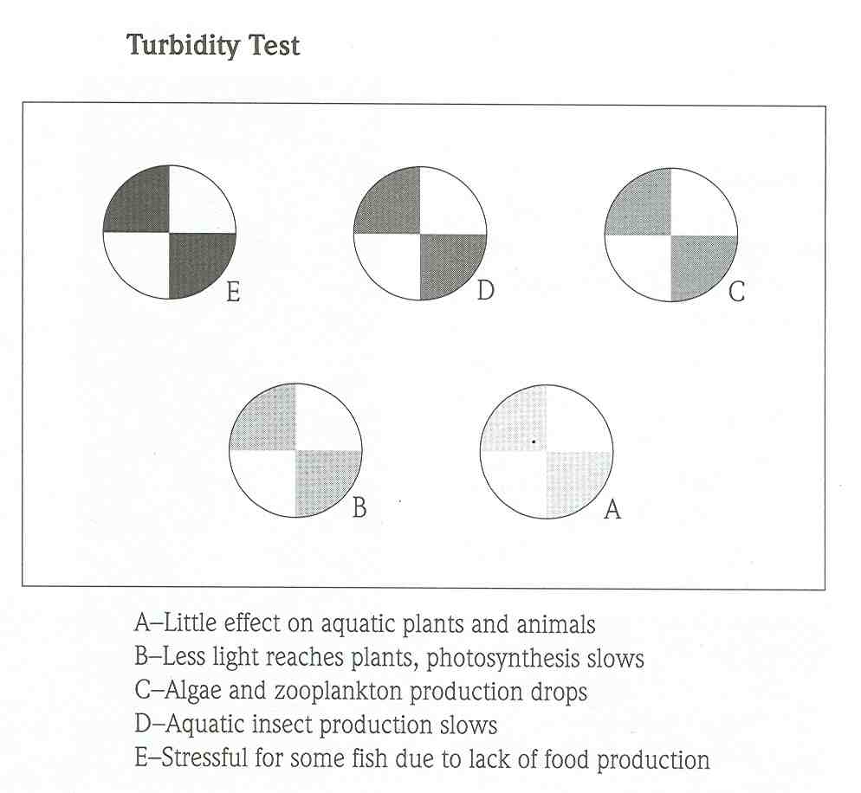
Note: if Turbidity > 100.0, Q = 5.0
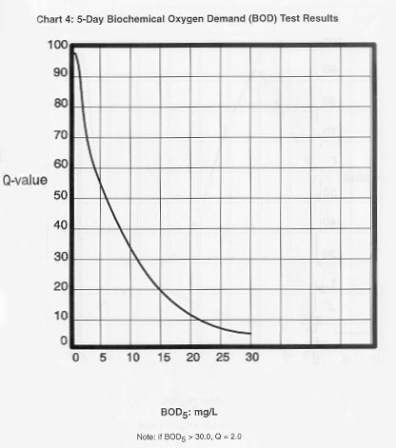
Station 4 - BIOLOGICAL TESTING

BIOLOGICAL OXYGEN DEMAND (BOD)
INSTRUCTOR WILL PROVIDE
- Your Instructor will give you a sample of water that has been kept in a dark bottle for 5 days at room temperature.
- Determine its DO following the directions in CHEMets Kit. Record your DO.
- Determine the BOD by subtracting the D.O. of the dark bottle from the Light Bottle D.O. Record the B.O.D.
- DISCARD SOLUTION INTO WASTE CONTAINER.

MACROINVERTEBRATE TESTING
- Using the nets and collection tools, look for macroinvertebrates.
- Use the macroinvertebrate key to determine types of species located and determine the group for each organism.
- Make a list of each species found. Tally the total number of each species within each tolerance level (Group 1, 2, or 3) based on the key.

CALCULATE THE CUMMULATIVE INDEX VALUE
Find the index value for each group as follows: Multiply the total number of Group 1 organisms by 3. Multiply the total number of Group 2 organisms by 2. Multiply the total number of Group 3 organisms by 1. Add up all index values for the cumulative index value. Determine Pond Quality based on the following values:
Cumulative Index Value | Pond Quality Assessment
23 and above | Excellent
17-22 | Good
11-16 | Fair
10 or less | Poor
CALCULATE THE WATER QUALITY INDEX (WQI)
For each test, multiply the Q-value by the weighing factor and place the product in the TOTAL column on the data table.
Add the TOTALs of all the tests then multiply this value by 1.19. (The 1.19 value takes into account the factor of fecal coliform bacteria which we did not measure.) Record this value as the Water Quality Index (WQI).

TEST | TEST RESULTS: | Q-VALUE or QUALITY: | WEIGHING FACTOR: | TOTAL:
Nitrates (NO₃⁻) | mg/L |  | .10
Phosphates (PO₄³⁻) | mg/L |  | .10
D.O. | mg/L
D.O. | % Saturation |  | .17
pH |  |  | .11
Iron
Copper
Hardness
Alkalinity
Temperature #1 | ºC
Temperature #2 | ºC
ΔºC | ºC |  | .10
TDS | mg/L |  | .07
TSS (Turbidity) | NTU |  | .08
B.O.D. | mg/L Dark D.O.
B.O.D. | Δ mg/L D.O. |  | .11
Macroinvertebrates | # Intolerant (Group 1)
Macroinvertebrates | # Moderate (Group 2)
Macroinvertebrates | # Tolerant (Group 3)
Fecal Coliform | colonies/100 mL |  | .16
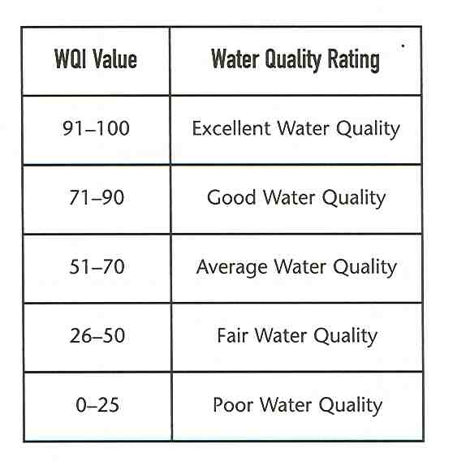
Water Quality Index (WQI) = _________________

Cumulative Index Value = __________________

POST-LAB QUESTIONS:

- Based on the WQI value for our Eco-Studies Pond, what would be its Water Quality Rating? Explain your overall pond assessment as it relates to WQI.
- Of all of the tests performed, which should have the greatest impact on the Water Quality Rating? Explain why.
- If our Eco-Studies Pond showed high NO₃ˉ levels, what might be the source?
- What might be the cause of high turbidity? Explain your answer.
- What might be two causes of a higher temperature in the different sides of the pond?
- What problem might result from a higher pond temperature?
- We did not test for fecal coliform bacteria. Why might this test not be necessary for our Eco-Studies Pond?
- Discuss the importance of the “other chemical” tests and what information can be learned from each.
- Explain how indicator species are used to assess water quality and explain why they are a good measure for determining water quality. (Hint: Compare your cumulative index value with your water quality index.)

